Puzzle - Serial Bluetooth 串口蓝牙模块

产品简介
Puzzle - Serial Bluetooth是一个在Puzzle平台上易用的蓝牙连接模块。它具有V2.0+EDR(Enhanced Data Rate)2Mbps调制功能，以2.4GHz作为基带，板上带有接收器。此串口蓝牙模块使用的是CSR Bluecore 04-External芯片，该芯片使用CMOS工艺制作，具有低功耗的优点。同时具有自适应跳频功能AFH（Adaptive Frequency Hopping），能够自动找到最适合的频段。是蓝牙项目的好选择。
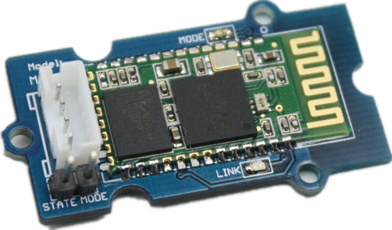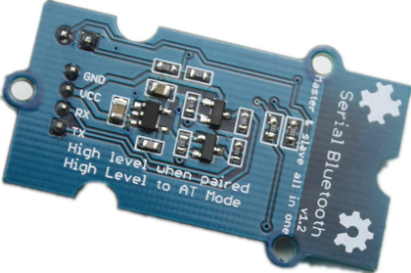
规格参数
- 工作电压: 5.0VDC
- 数据传输速度: 2Mbps
- 最大发射功率：+4dBm
- 灵敏度：-80dBm
- 全功能蓝牙V2.0+EDR 3Mbps调制
- 可选波特率
- 30s自动连接

应用示例
这个模块的库文件里我们打包了让Puzzle - Serial Bluetooth工作在主机模式或从机模式的两个demo。
两个蓝牙设备之间是这样子工作的：

首先将蓝牙模块连接到Puzzle - Base Shield的D6上：

下载并安装“参考资源”部分中提供的库文件。如果你希望蓝牙模块工作在主机模式，则按以下路径打开demo：File - Examples - Bluetooth_demo_code - Master。从机模式也是以同样的路径打开的。
Puzzle - Serial Bluetooth处于配对状态是，绿色LED和红色LED会交替亮起。如果连接成功，则绿色LED以2s为周期闪烁，否则红色LED以0.5s为周期闪烁。

参考资源
- 库文件
- 电路图文件
- 软件介绍
- 蓝牙模块数据手册

拓展阅读
Flowchat

Commands to change default configuration
1. Set working MODE
\r\n+STWMOD=0\r\n | Set device working mode as client (slave). Save and Rest.
\r\n+STWMOD=1\r\n | Set device working mode as server (master). Save and Rest.
Note: \r\n is necessary for operation and the value of are 0x0D 0x0A in Hex. \r and \n represent carriage-return and line-feed(or next line),
2.Set BAUDRATE
\r\n+STBD=115200\r\n | Set baudrate 115200. Save and Rest.
Supported baudrate: 9600, 19200,38400,57600,115200,230400,460800.
3. Set Device NAME
\r\n+STNA=abcdefg\r\n | Set device name as “abcdefg”. Save and Rest.
4. Auto-connect the last paired device on power
\r\n+STAUTO=0\r\n | Auto-connect forbidden. Save and Rest.
\r\n+STAUTO=1\r\n | Permit Auto-connect. Save and Rest.
5. Permit Paired device to connect me
\r\n+STOAUT=0\r\n | Forbidden. Save and Rest.
\r\n+STOAUT=1\r\n | Permit. Save and Rest.
6. Set PINCODE
\r\n+STPIN=2222\r\n | Set pincode “2222”, Save and Rest.
7. Delete PINCODE(input PINCODE by MCU)
\r\n+DLPIN\r\n | Delete pincode. Save and Rest.
8. Read local ADDRESS CODE
\r\n+RTADDR\r\n | Return address of the device.
9. Auto-reconnecting when master device is beyond the valid range (slave device will auto-reconnect in 30 min when it is beyond the valid range)
\r\n+LOSSRECONN=0\r\n | Forbid auto-reconnecting.
\r\n+LOSSRECONN=1\r\n | Permit auto-reconnecting.
Commands for Normal Operation:
1. Inquire
a) Master
\r\n+INQ=0\r\n | Stop Inquiring
\r\n+INQ=1\r\n | Begin/Restart Inquiring
b) Slave
\r\n+INQ=0\r\n | Disable been inquired
\r\n+INQ=1\r\n | Enable been inquired
When +INQ=1 command is successful, the red and green LEDS blink alternatively.
2. Bluetooth module returns inquiring result
\r\n+RTINQ=aa,bb,cc,dd,ee,ff;name\r\n | Serial Bluetooth device with the address “aa,bb,cc,dd,ee,ff” and the name “name” is inquired
3. Connect device
\r\n+CONN=aa,bb,cc,dd,ee,ff\r\n | Connect to a device with address of "aa,bb,cc,dd,ee,ff”
4. Bluetooth module requests inputting PINCODE
\r\n+INPIN\r\n
5. Input PINCODE
\r\n+RTPIN=code\r\n
Example: RTPIN=0000 | Input PINCODE which is four zero
6. Disconnect device Pulling PIO0 high will disconnect current working Bluetooth device.
7. Return status \r\n+BTSTA:xx\r\n
xx status:
- 0 - Initializing
- 1 - Ready
- 2 - Inquiring
- 3 - Connecting
- 4 - Connected
(Note: This is not a command, but the information returned from the module after every command)

